Contents

Introduction……………………………………………………………...3
Actuality ……………………………………………………………...…5

Chapter I………………………………………………………………...6
1.1 From the history of Motanka doll………………………..................6
1.2 From the history of Tilda doll……………………………………... 7
1.3 Kinds and peculiarities of Motanka dolls …..……………..…….....8
1.4 Kinds and peculiarities of Tilda dolls……………………………....9
1.5 A comparative table of the features of Motanka and Tilda dolls….10

Chapter II…………………………………………………………...…11
3.1 Social Survey ….………………………………………….…........11
3.2The analyses of the survey……………………………………….. .13
3.3 The result of our work…………………………………………….14
Conclusion……………………………………………………….........15
Bibliography……………………………………………………..........16
Supplement 1…………………………………………………….........17
Supplement 2…………………………………………………….........19
Supplement 3 …………………………………………………………20
Supplement 4 …………………………………………………………21
Supplement 5………………………………………………………….27
Supplement 6………………………………………………………….28

THERE IS NO FUTURE WITHOUT PAST

Introduction

«From all the world's mysteries the secret of the doll is the most mysterious one, not understanding the essence of the doll it is impossible to understand the human."
M. E. Saltykov-Shchedrin

Anyone remembers the toys of his childhood regardless of age, profession, the place he lives in. We suggest that every family has dolls either bought or handmade ones that are treated with respect and love.
Dolls are an integral part of the world of toys. Dolls were always played at all times. In different countries, in different cultures dolls were not only children's toys but also objects related to religion and rituals. They were made in connection with national holidays, family events, as presents and protectors of homes, health, beauty and wealth. Protecting dolls had magical significance for our ancestors, serving as mediators between people and the other world.
Unfortunately, in our modern world we have lost a lot of national traditions.
The same has happened to the true purpose of dolls. Luckily nowadays more and more people turn back to their roots and traditions, one of which is making Belarussian national dolls.

The main aim of our work is to trace the role of dolls in people's lives in different historical times, to compare and systematize the information about national traditional dolls of Belarus and to prove their significance for our culture and family traditions.

The objectives of the project:
• To learn the history of some Belarusian folk dolls and modern handmade ones.
• To define their kinds and purposes.
• To learn the process of their creating.
• To compare and analyze Motanka and Tilda dolls.
• To conduct a survey among schoolchildren of primary and secondary school in order to find out the information about their favourite handmade dolls.
• To make Tilda and Motanka dolls to show their importance for our culture and traditions.

The object of the work is handmade dolls.

The subject of the work is the role of folk dolls in our life.

Hypothesis: Supposing that modern Tilda doll has similarity with Belarusian Motanka doll, they both help to revive the interest towards rich folk traditions of Belarusian people.
The methods of our research are:
• studying and analyzing different sources of information (books, reference books, the Internet sources)
• questioning
• analyzing the results of questionnaires
• summarizing the information
• making Tilda and Motanka dolls

Actuality of the project

The world of dolls is full of surprises and mysteries. The doll is the first among toys. It has been known since ancient times, remaining forever young. Its history has been traced since the construction of the Egyptian pyramids to the present day. Time does not affect it and it still finds its way to the hearts of children and adults.
Wherever a person lives, from the harsh snowy Arctic expanses to the waterless desert, the doll is our constant companion. It is simple, but there is a great mystery in this simplicity. The doll is not born by itself: it is created by people. It gets life through the imagination and will of its creator. Being a part of the culture of all the mankind, the doll reflects the identity and characteristic features of the nation creating it.
Historically, the functions of dolls changed. First, human figures from clay were installed as guardians of the dead. Later they were sacrificed to the gods, to protect themselves from misfortunes and diseases.
People began to worship the gods, to ask for mercy and protection. So there appeared the idols and statues –the images of the gods. They were usually made in the form of human figures. So it turns out those were the very first dolls.
Having learned the history, we can see that in the ancient world dolls were used not only for gaming, but for ceremonies as well. Those were the ancestors of folk toys.
So, the doll is a toy made in the form of human figures. It means that people tried to show the similarity of the dolls with humans. And it's worth thinking about. In Russian, the word "doll" is an animate noun. Animate means it has a soul! Its creator puts his soul into his work. He believes that such a doll will help in sorrow and share happiness.
Dolls can differ in
- appearance;
- the complexity of their creating;
- traditions and places of origin;
- material
- functional features
Folk dolls according to their purpose are divided into three large groups:
- amulet-dolls
- dolls for games
- ritual dolls
We can’t say that folk dolls are just our past. Folk art attracts more and more people nowadays and arouses a great interest in national traditions in the process of creating dolls. At present a lot of folk art studios are opened proposing numerous master classes on the creation of handmade dolls. It means that there is a place for simple and beautiful handmade toys even in the era of the Internet and computer games. We think that the folk doll is reviving and contributing much to our life.

Chapter I

1.1 From the history of Motanka doll

Motanka dolls were made exclusively by women. Men were not even allowed to look at this process. Before starting to make dolls the woman had to say spells and set themselves in a special way. There was an opinion that the well-being and fate of the family and family depended on the quality of the hostess's work. After all, the Slavic Bereginya dolls were the protectors of the house, family and clan. It meant that the woman had to treat to that process with great responsibility and very seriously. The significance of the dolls was very huge.
The first tie-dolls, usually known as Motanka, appeared about 5,000 years ago. Motanka is a symbol of goodness and prosperity, a symbol of hope for the best and the strongest sacred object. And it didn’t matter much either that doll was created for games and fun for the child in haste or as an important amulet or a gift for some holidays.
The name of the doll “motanka" comes from the notion of "winding up", and the whole appearance of a doll is a figure of a woman or a child made of pieces of fabric. The doll’s body parts were tied with the help of knots. Each doll was a unique work of the master. Of course in ancient times Motanka doll played an important role as an amulet and talisman for the family.
The appearance of Motanka doll is connected with the beginning of growing flax, hemp and nettle. It was believed that tying knots, winding up and twisting of dolls let people be closer to their gods and ancestors and served for sharing the experience from one generation to another. Such dolls were usually made on holidays connected with farming at the end of Maslenitsa and on Kupalle.
Motanka doll was made from all available materials in the household but without any thread or other tools. One of the most valuable decorations was a shred of old clothes with embroidery.
Such dolls often became real family relics and handed down from generation to generation. The first doll was made by a girl at the age of 12-13 years old. The quality of the doll was considered to be ready for marriage. The most beautiful handmade dolls were kept in a chest and were a part of dowry. Also such dolls were often used in wedding rituals and traditions.

1.2 From the history of Tilda doll

If we look up into the encyclopedia we will find out that Tilda is a doll, a small animal or an object of the interior made according to the patterns of the Norwegian artist Tone Finnanger. Tilda toys are made in a primitive rag style. Nowadays they are incredibly popular in Europe and have recently gained their popularity in our country.
Tone Finnanger's hobby began with her work in a small shop where hand-made goods were sold. Before that, she wanted to make a career as a children's writer and illustrator. For Tone working in the store was a source of inspiration and let her hobbies become profession. First, Tone just wanted to create something really cozy, homely, warm and dear to her heart. She had flaps of light natural fabrics, needle and thread. Without long thinking Tone sewed the world's first Tilda doll in 1999, and then she opened her own shop named “Tilda”. Later Tone wrote and published some books about the process of sewing Tilda dolls. A year later she signed a contract with Panduro Hobby and started the production of her own Tilda toys. Thus, their goods and books have become extremely popular in the world.
Tilda stores sell goods for needlework and patterns. And still there are no ready dolls there because the main purpose is to create a masterpiece with your own hands and give it a unique character.
As for the name Tilda is concerned, the answer is rather vivid. Tilda is a female name, derivative of Matilda, of German origin, popular in Italy, Germany and Scandinavian countries. In translation, Matilda means a strong warrior. Tone herself was born and brought up in Norway, in the country where girls are often called Tilda.
Tone has chosen this very name for one more reason. All the names in her own family start with the letter „T“, even the name of their dog Torro.
Tilda is not only related to Scandinavian style. For recent years Tilda has been changing a lot. Of course, Scandinavian folklore and children's memories of the author were the main source of inspiration in its creation but it was influenced by the authors and artists from other countries and Belarus as well.

1.3 Kinds and peculiarities of Motanka dolls

On the whole, there are three groups of Motanka dolls: babies, brides and Bereginia dolls.
- Motanka dolls for newborns are also called Pelenashka dolls. Mothers or grandmothers made them for newborns. Pelenashka dolls protect the baby from diseases and an evil eye, bring a restful sleep. If a child suffered from an illness Pelenashka doll took the disease on itself, in this case it was burned so that the sickness would not return.
- Motanka doll in a wedding dress was a doll-amulet for brides. After the wedding the wife used to play with it until the birth of a child to keep away the evil forces.
- There are some kinds of Bereginya dolls - Easter, Fertile, Zhelannitsa, Travnitsa and others. These dolls were used to protect the house and people living in it. Bereginia dolls protected from an evil eye, damage, misery, grief, bad words and evil people. (Supplement 1)

Motanka doll is made without any stitches. To make a doll a master winded or wrapped it with some fabric and thread and used tapes and threads for fixing its details with the help of knots. The main requirement for making the doll is a cross-shaped form.
In general, the creation of such a doll can become an exciting activity for adults and children and will help to revive native traditions and create a unique amulet or a souvenir.
The head of the doll is formed from a small piece of fabric, inside which a ball of thread, some patchwork or cotton wool is put. This head is wrapped with thread criss cross thus symbolically depicting the face of the doll. The head and the body are also tied with threads. Clothes, jewelry and hats or hairstyles are made from improvised materials. Patterns on fabric for clothes have their own meaning.
The word "pattern" meant "patron". That is why people embroidered different signs on dolls’ clothes such as circles, crosses, rosettes, sun, lines and so on. (Supplement 2)
A traditional rag doll is faceless. The face, as a rule, is not indicated and remains white. A doll without a face was considered an inanimate object, inaccessible to evil, unkind forces and therefore harmless for the child. It used to bring him well-being, health, joy. It was a miracle: the character of the doll was reflected even without hands, legs and a definite face. The doll could be different, it could laugh and cry.

1.4 Kinds and peculiarities of Tilda dolls

Tilda dolls have many different images. They can be not only in the form of tiny people. Cats, rabbits, bears, angels, dogs, elephants and many other animals can be Tildas as well. The most popular of them are sleepy angels and rabbits, Santas, snowmen, flying cats, Sweetheart dolls. (Supplement 3)
The technology of sewing Tilda doll is very important. There is one main peculiarity that distinguishes Tilda among other toys. Tilda has small dots instead of eyes and a blush on its cheeks. It is customary to embroid eyes with the threads of moulinet using French small knots. Also eyes can be painted with acrylic paints for painting on fabric. Some masters sew beads as eyes. Tilda's face always has a playful blush. It is made with the help of a brush or sponge with the simplest cosmetic rouge. You can also paint a blush with acrylic paints or shavings from a red pencil.
A distinctive feature of Tilda dolls is their tan. The bodies of the dolls are sewn from colored fabric. Materials are coloured with tea, coffee or cinnamon.
Often such dolls are made from natural fabrics such as satin, linen, cotton, wool, jeans and even silk.
Usually the doll's clothes are sewn to its body. Its legs are stitched in the place of knees so that the doll can sit. The same is done with its arms that are stitched in the place of elbows. When all the details are sewn they are stuffed with the filling (cotton, wool or any soft material). Arms and legs are stuffed not so dense as its head and body. All parts of the doll are sewn with a hidden seam.
If you want to give the toy a desirable flavor you can add natural vanillin, cinnamon and herbs such as mint, lavender, jasmine and chamomile in its filling. Sometimes the packets of fragrant herbs are put inside the doll. You can also make the toy heavier using sea salt.
It is believed that Tilda dolls are not for playing. They are more related to interior toys. They are used as decorations or souvenirs.

1.5 A comparative table of the features of Motanka and Tilda dolls

We have compared different aspects connected with Motanka and Tilda dolls to learn their similarity and peculiarity.

 | Tilda dolls | Motanka dolls
Appeared | 1999 | more than 5000 years ago
Purpose | - Interior  - Decoration  - Souvenir | - Protector (earlier)  - Ritual (earlier)  - Toy (earlier)  - Interior (now)  - Souvenir (now)
Connection with rituals  and traditions | no connection | - protected from evil, unkind forces; connection with traditional holidays
Materials | natural fabrics | natural fabrics and thread
Similarity in appearance | - no nose or mouth  - each doll is unique | - each doll is unique  - no nose or mouth
Peculiarities in appearance | - small dots instead of eyes  - blush on cheeks | - faceless  - without hands, legs  - a cross-shaped form
Technology | - hand-made  - sewing | - hand-made  - wrapping and winding

Having analyzed the table we can make a conclusion that in spite of different time of appearance both dolls have such similar aspects as material they are made from, some facial features and their purpose nowadays. Still the main differences are lack of connection of Tilda dolls with rituals and traditions and the technology of making both dolls.

Chapter II

2.1 Social Survey (Supplement 4)

We have interviewed 100 respondents of 5-10 forms. Among them there were 40 boys and 60 girls of different ages. They were to answer 11 questions about different kinds of dolls, their appearance, purposes and features.

- Do you know when dolls first appeared on the territory of Belarus?
- Yes – 17
- No – 83

- Do you have dolls at home?
- Dolls for playing - 61
- Dolls souvenirs - 48
- Dolls for interior - 30

- Do you know what purpose Bereginya dolls have?
(If yes – point out them)
- Yes – 16
Protect – 15
Bring happiness - 1
- No – 84

- Do you know any information about Motanka doll?
- Yes – 14
- No – 86

- Do you know any information about Tilda doll?
- Yes – 17
- No – 83

- Have you ever made a doll?
- Yes – 45
- No – 55

- Do you think Tilda doll and |Motanka doll are quite similar?
- Yes – 13
- No – 87

- Do you know the meaning of the ornament on dolls’ clothes?
- Yes –12
- No – 88
- Do you know why Motanka doll is faceless?
- Yes – 35
- No – 65

- Would you like to learn more about Tilda and Motanka dolls and create a handmade doll?
- Yes – 59
- No – 41

- Do you agree that handmade dolls (for example Motanka doll) can help to revive the interest towards the heritage of Belarussian culture? (If yes – in what way)
- Yes – 88 (They help to know more about the history and traditions of Belarus)
- No – 12

2.2 The analyses of the survey

We have analyzed the answers of the respondents and found out that the majority of boys are sceptical towards dolls in general. Very few students know about the time of appearance of dolls in Belarus (17 %), the history of Motanka doll (14 %) and Tilda doll (17 %) and only 13 % are sure that these dolls have much in common. They also have little information about the purpose of Bereginya dolls (84 %) and the meaning of the ornament on dolls’ clothes (88 %).
But at the same time 61 % of the respondents have dolls for playing, 48 % have souvenir dolls and 30 % have interior dolls.
35 % know why Motanka doll is faceless. 45 % made a handmade doll themselves (mostly Tilda dolls) and 59 % would like to make it and learn more about Tilda and Motanka dolls.
According to the survey we see that 88 % of the students think that handmade dolls (for example Motanka doll) can revive the interest towards the heritage of Belarussian culture as they help to know more about the history and traditions of Belarus.

2.3 The result of our work

We have created Tilda and Motanka dolls in national Belarussian costumes to make our schoolmates interested in our cultural heritage, to acquaint them with the history of folk and modern handmade dolls, to show their role in modern life. (Supplement 5)
We have learned the traditional technologies of creating Motanka dolls and modern technologies of making Tilda dolls. We have chosen Pelenashka doll for demonstration of winding and wrapping technology.
For "napkins" take pieces of cotton fabrics of calm tones. And for the body of the doll you may take an old, unnecessary sheet. Cut a piece about 80x35 cm, fold it in half and twist into a tight tube. Tie the body with a thick thread to mark the head and the chest. And then wrap it with colored rags and a ribbon. That is all! (Supplement 6)
We hope that our work will be useful for our peers and they will be able to make their unique rag dolls giving them love, warmth and caress.

Conclusion

When there were no toy shops in every house and in every family children had dolls. Initially, the doll was a protector and a ritual symbol. It gradually turned into a favourite entertainment for children.
The most common toy for girls was a rag doll. Such dolls were kept in families and handed down from one generation to another. Rag dolls were in every family.
Each rag doll was unique. But traditionally all of them were divided into groups according to the method of technology and purpose.
In addition to its entertaining function a traditional folk doll had the educational one. The girl was taught cooking, measuring the proportions of the products with the help of the doll. And, of course, with the help of dolls girls got ready to become mothers in future.
Obviously the basis of the world-view was traced in all those dolls. Everything that surrounded people, everything they saw was reflected in dolls.
Nowadays handmade dolls serve also as a decoration and a souvenir. But still many families believe in their power and consider them as protectors. More and more people get interested in creating traditional dolls.
On the territory of Belarus there are a lot of museums devoted to folk dolls. Every year different master classes, festivals and holidays are held in many towns, villages and cities where you can learn how to make a traditional doll. Therefore the traditions of our Belarusian people are not lost.
We have proved some similarity of modern Tilda doll with Belarusian Motanka doll. And we can say they both can help to revive the interest towards rich folk traditions of Belarusian people.

Bibliography

- Зимина, З.И. Текстильные обрядовые куклы/ З.И. Зимина// М.: Издательство «Ладога-100».- 2007.– 64 с.
- Шайдурова Н.В. Традиционная тряпичная кукла/Н.В. Шайдурова// Издательство «Детство-Пресс». – 2015. – 176 с.
- Финнангер, Т. Тильда: Куклы/ Т. Финнангер// М.: Издательство «Арт-родник». – 2014. – 48 с.
- Мюллер В. К. Современный англо-русский, русско-английский словарь/ В. К. Мюллер// М.: ДОМ. XXI век. - 2010. – 957 с.
- http://womanwiki.ru/
- http://slavyanskaya-kultura.ru/slavic/trade/slavjanskie-kukly-oberegi.html
- http://kuklopedia.ru/doll/

Supplement 1

Pelenashka dolls

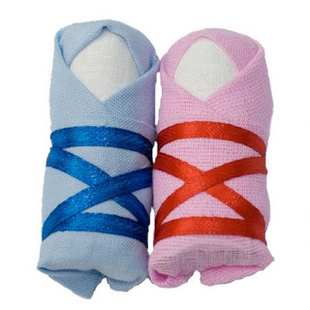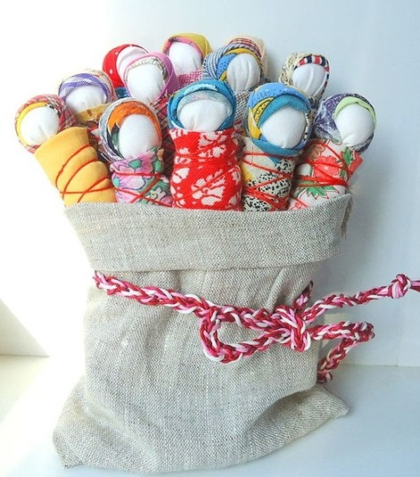

Amulet dolls for brides

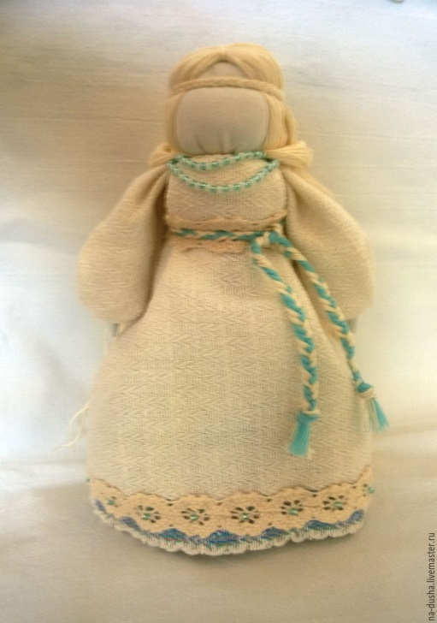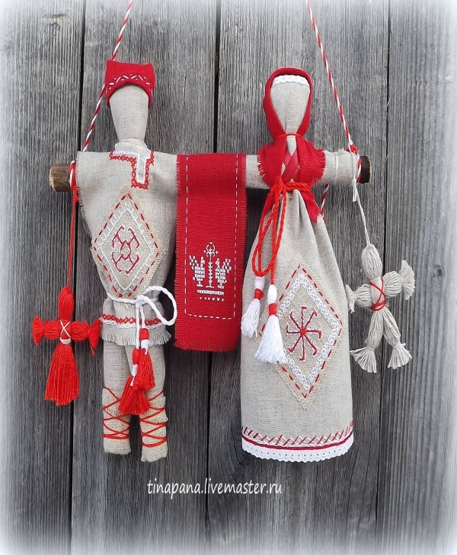

Bereginya dolls

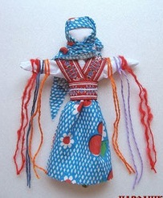

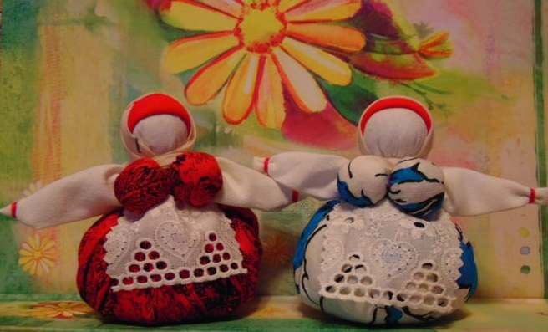

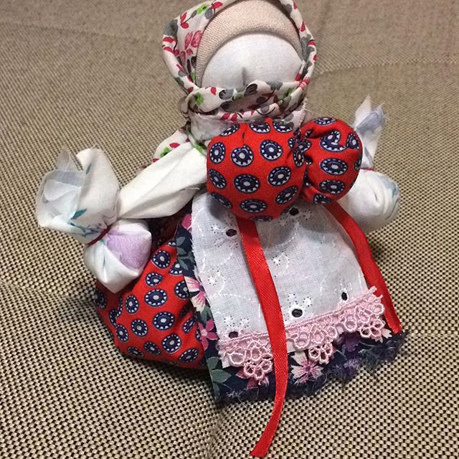
Supplement 2

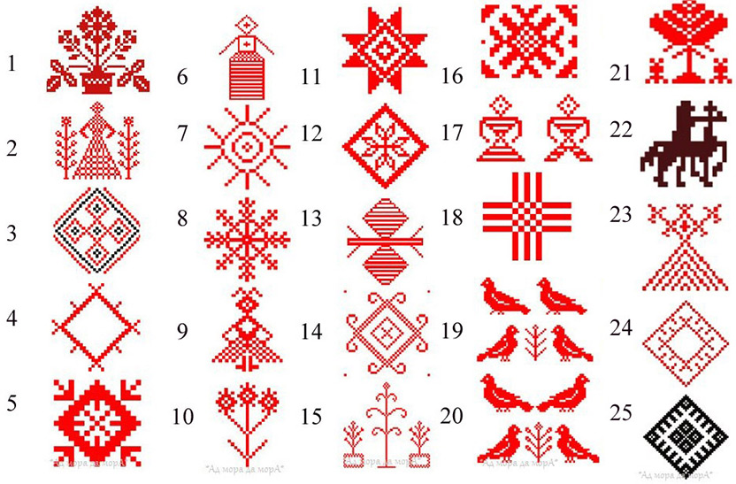
- The symbol of women’s lot
- Mother and a saint tree
- The symbol of a close-knit family
- The symbol of the sun
- The symbol of wealth
- The symbol of Bereginya
- The symbol of Kupalle (round dance)
- The symbol of Kupalle (fire)
- The symbol of Kupalle (dancing Kupalinka)
- Paparats kvetka
- The symbol of children (protection from misfortune)
- The symbol of mother
- Protector
- The symbol of love song
- The symbol of birch-girl
- The symbol of Yaryla
- The symbol of wedding
- The symbol of ancestors
- The symbol of mutual love
- The symbol of unshared love
- The symbol of life tree (immortality)
- Yaryla on the horse (harvest and nature)
- Zhytnya baba (the symbol of harvest and life)
- The symbol of coming spring
- The symbol of the sun
Supplement 3

Tilda dolls

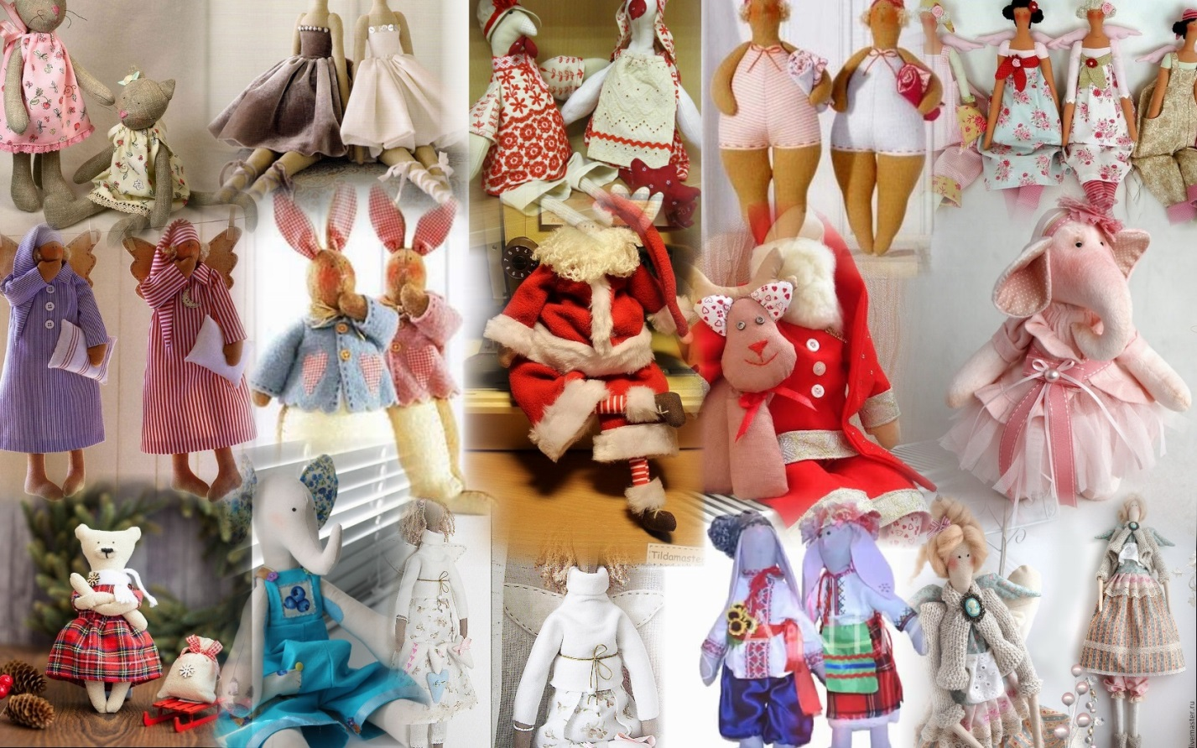

Supplement 4

Supplement 5

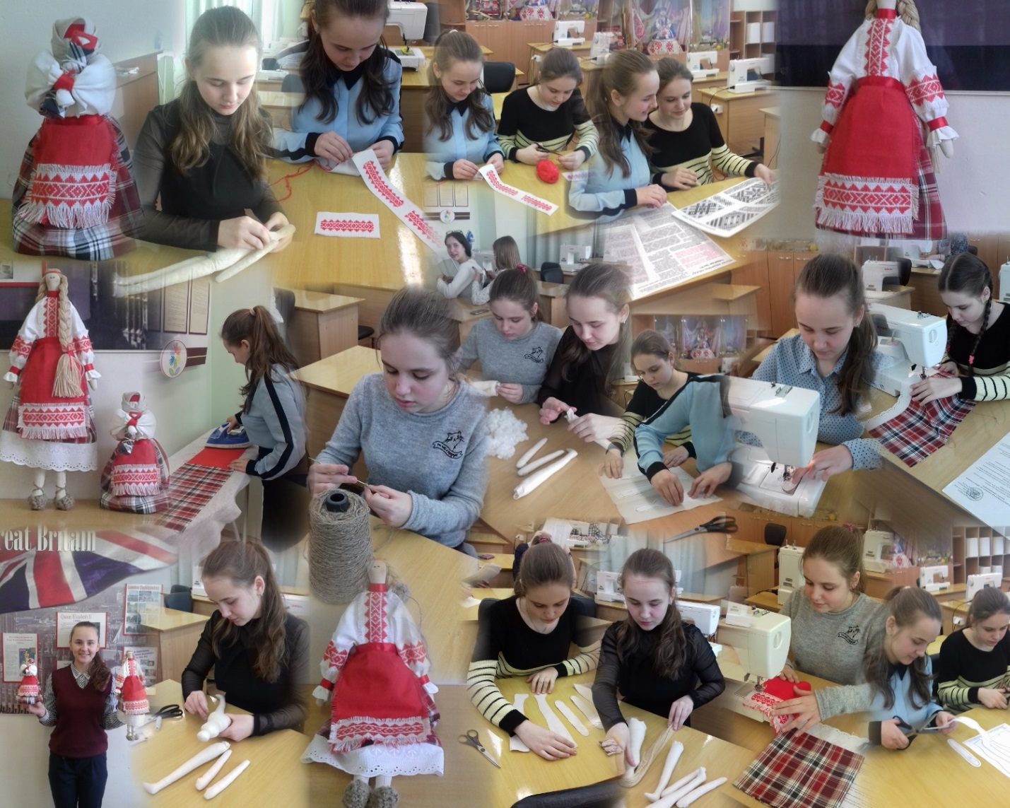

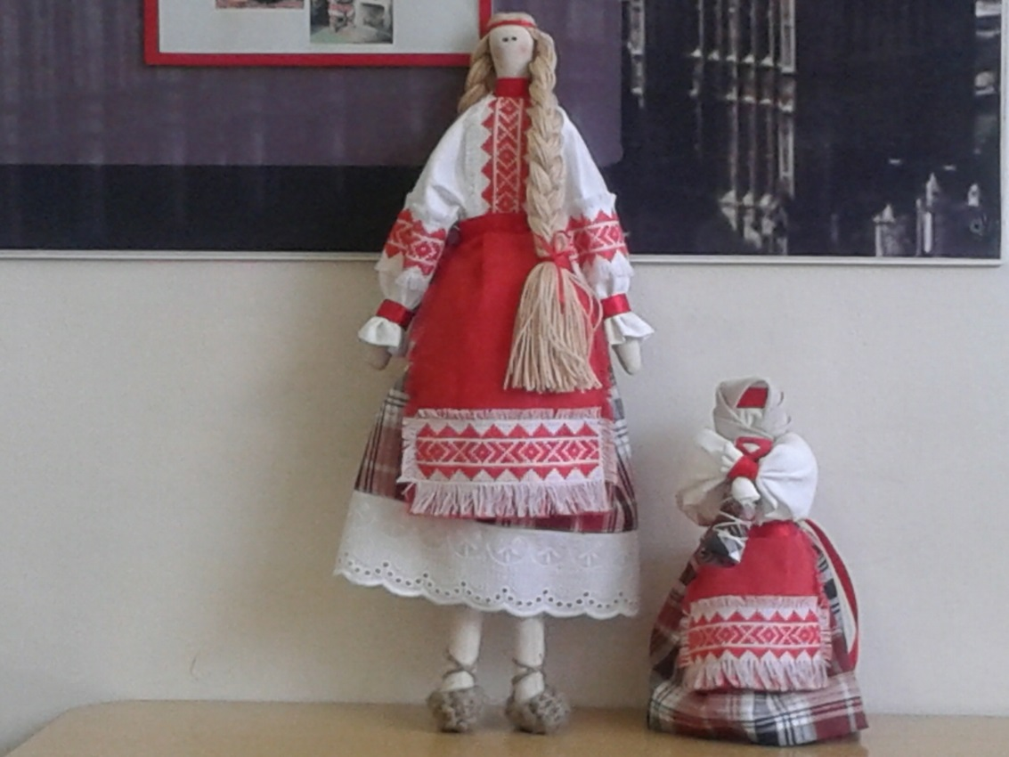
Supplement 6

The steps of making Pelenashka doll

