Research laboratory report

Food Chemistry

Presence of starch in chickpea seeds

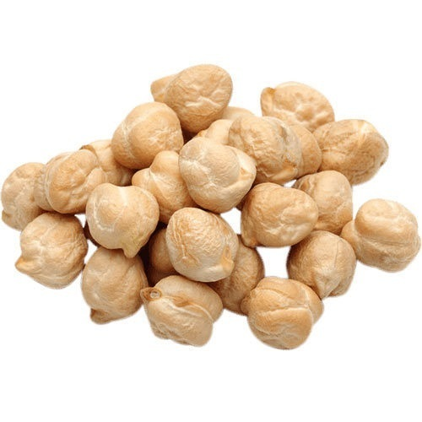

Student name: Zhumazhanova Gulderay

Name research lab simulation: Carbohydrates

**Abstract**

Carbohydrates | 2

The chickpea seeds were researched. Main research objectives 1. Detect the presence of starch in chickpea seeds. 2. Isolate the starch from chickpea seeds and determine the yield of isolation on a dry basis. 3. Determine the size and shape, and location of the hilum of the isolated chickpea starch granules. 4. Identify the behavior of gelatinization of isolated chickpea starch. 5. Make a starch solution from the isolated chickpea starch. Hydrolyze the starch solution in two different ways and figure out the degree of hydrolysis.

Using an iodine test, the presence of starch in chickpea seeds was detected. Amylose, which is present in the starch, is responsible for the formation of an intense blue-black color in the presence of iodine. Starch was isolated from chickpea seeds with a yield of 41.6% on a dry basis. Granule size 10-20 μm,  shape is elliptical (oval), and hilum is located within the central dimple. The gelatinization behavior of isolated chickpea starch was detected. It was found that the start of gelatinization is at 64.9 °C, peak gelatinization at 70.4 °C, and retrogradation at 50.1 °C. A solution of glucose or maltose, or a mixture of glucose, maltose and oligosaccharides was obtained using an acidic and enzymatic method. Overall, from the experiments it can be concluded that the presence of starch in chickpea seeds increases the efficiency and quality of chickpea.

**Table of Contents**

Carbohydrates | 3

1. General introduction ……………………………………………………………………. 4
2. Materials and Methods ……………………………………………………………………5
   1. Materials ……………………………………………………………………………..5
   2. Presence of starch .................................................................................................5
   3. Starch isolation .....................................................................................................5
   4. Morphology of starch granules .............................................................................5
   5. Gelatinization behavior of starch ..........................................................................5
   6. Prepare starch solution ..........................................................................................5
   7. Acid hydrolysis of starch ......................................................................................6
   8. Enzymatic hydrolysis of starch .............................................................................6
   9. Reducing sugar content .........................................................................................6
   10. Total (soluble) carbohydrates ......................................................................6
3. Results and Discussion …………………………………………………………………..6
   1. Presence of starch .................................................................................................6
   2. Starch isolation .....................................................................................................6
   3. Morphology of starch granules .............................................................................6
   4. Gelatinization behavior of starch ..........................................................................7
   5. Prepare starch solution ..........................................................................................7
   6. Acid and enzymatic hydrolysis of starch …………………………………………..7
   7. Reducing sugar content .........................................................................................7
   8. Total (soluble) carbohydrates ................................................................................8
   9. Research ……………………………………………………………………………..8
   10. Discussion …………………………………………………………………….9
4. Conclusions ……………………………………………………………………………....9
5. References ………………………………………………………………………………..10
6. Appendix …………………………………………………………………………………10

6.1. Raw chickpea seeds …………………………………………………………………10

6.2. Presence of starch ……………………………………………………………………10

6.3. Starch isolation ………………………………………………………………………10

6.4. Morphology of starch granules ……………………………………………………...11

6.5. Gelatinization behavior of starch ……………………………………………………11

6.6. Acid hydrolysis of starch ……………………………………………………………12

6.7. Reducing sugar content …………………………………………………………….12

6.8. Total (soluble) carbohydrates ……………………………………………………..12

**1. General introduction**

Carbohydrates | 4

The main research material is chickpea seeds. The seeds of chickpea, are large in size, salmon-white in color, and contain high levels of carbohydrate (62.50%) and protein (23.50%). Starch is the major carbohydrate fraction, representing about 80.0% of the total carbohydrates. Dry matter content: 87.5%. The chickpea seeds from this study of the biotype Kabuli, provided by the (imaginary) company CanaPeas from Canada.

Starch is extracted from chickpea seeds. Starch is the major carbohydrate fraction in chickpea seeds, and is made up of two large glucan polymers: amylose (30-40%) and amylopectin (60-70%), respectively. Amylose is responsible for the formation of an intense blue-black color in the presence of iodine. The helix shaped amylose encloses the iodine, making a linear triiodide ion (I3-) complex that causes the intense blue-black color. In the absence of starch, the orange-brown color of iodine in aqueous solution remains.

"Presence of starch" section. With the iodine test, I test a sample for the presence of starch.

“Starch isolation” section. Depending on the botanical origin and genetic background, starch has different chemical structures and different functional properties. To be able to investigate these chemical structures and functional properties in chickpea starch, it must first be isolated from the seeds. This is done by milling and screening of the starch granules through a nylon cloth.

“Morphology of starch granules” section. Using a polarization microscope, one can characterize the morphological properties, i.e. size and shape, and location of the hilium of starch granules.

“Gelatinization behavior of starch” section. When heated in water, starch undergoes a transition process. Starch granules break down into a mixture of polymers in solution due to uptake of water, causing loss of crystalline structure paired with swelling, known as gelatinization. The process of gelatinization can be followed with use of a Brabender Visco-Amylo-Graph.

Research assignment goals:

1. Demonstration the presence of starch in chickpea seeds.

2. Isolation starch from chickpea seeds and determination the yield of isolation on a dry basis.

3. Determination the size and shape, and location of the hilum of the isolated chickpea starch granules.

4. Identification of the gelatinization behavior of isolated chickpea starch.

5. Making a starch solution from the isolated chickpea starch.  Hydrolyzation the starch solution by two different methods, and determination the degree of hydrolysis.

Hypotesis of research assignments:

1. It is hypothesized that starch is present in chickpea seeds.
2. It is hypothesized to isolate starch from chickpea seeds with a yield of 40% on a dry basis.
3. It is hypothesized that isolated chickpea starch granules are elliptical, with a central dimple (the hilum of the starch granule). Size is hypothesized to be within range of 10-20 μm.
4. It is hypothesized to observe the start of gelatinization at 60-65 °C, peak gelatinization at 65-70 °C, and retrogradation at 50-55 °C for chickpea starch.
5. Based on the first twenty minutes of acid and enzymatic hydrolysis, it is hypothesized to observe a lower degree of hydrolysis for acid hydrolyzed chickpea starch than enzymatic hydrolyzed chickpea starch.

**2. Materials and methods**

Carbohydrates | 5

**2.1. Materials**

The chickpea seeds from this study of the biotype Kabuli, provided by the (imaginary) company CanaPeas from Canada. The seeds of chickpea, are large in size, salmon-white in color, and contain high levels of carbohydrate (62.50%) and protein (23.50%).

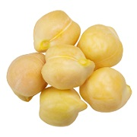

Sources: sodium hydrogen sulphite , slurry of ground chickpea seeds, demineralized water, ice, copper reagent, phenol solution, H2SO4 with a dispenser.

Equipments: pestle and mortar, test tube, pasteur pipette, Retsch mill, beaker glass, nylon loth, refrigerator. centrifuge tubes, oven, microscope, cover glass, Brabender Viscograph, Vortex, 150 mL beaker, magnetic stirrer, heating plate, graduated cylinder, aluminum foil, container with ice, boiling water bath, spectrophotometer, cuvette.

**2.2. Presence of starch**

With this method the presence of starch in chickpea seeds was demonstrated (assignment 1). Starch granules reacted with iodine, then formed a blue-black color. This indicates that starch is present. The helix shaped amylose encloses the iodine, making a linear triiodide ion (I3-) complex that causes aforementioned intense blue-black color.

**2.3. Starch isolation**

Starch was isolated from chickpea seeds (assignment 2). Sodium hydrogen sulfide was added to the soaking water, thereby increasing the rate of water diffusion into the seeds. Chickpea seeds were grinded using a Retsch mill. The obtained filtrate was settled in a refrigerator. The soluble layer (supernatant) was removed from the insoluble layer (granule) by suction. The granule was resuspended in demineralized water and centrifuged in centrifuge tubes. A white layer was obtained.

**2.4. Morphology of starch granules**

The size and shape, and location of the hilum of the isolated chickpea starch granules were determined (assignment 3). A suspof starch was made on a microscope slide. With this method was discovered that isolated chickpea starch granules are elliptical, with a central dimple (the hilum of the starch granule).

**2.5. Gelatinization behavior of starch**

The gelatinization behavior of isolated chickpea starch was determined (assignment 4). 5g of starch was dissolved in 110 mL demineralized water. The stirred suspension was transferred to the measuring vessel of the Brabender Viscograph. Temperatures for different situations were written.

**2.6. Prepare starch solution**

A **starch solution** was made from the isolated chickpea starch (assignment 5). 1g of starch was suspended in 5 mL deminerlized water , using a test tube. The starch suspension was added to the water, and a homogeneous (opalescent) solution was formed.

**2.7. Acid hydrolysis of starch**

Cabohydrates | 6

The starch solution was hydrolyzed by acid method and the degree of hydrolysis was determined (assignment 5). 4 ml 4M HCL solution was added to 25 ml of starch solution. Pipette 5 ml of the aforeobtained solution was placed in 5 tubes and covered with aluminum foil. The method of incubation, boiling water bath, and ice were used.

**2.8. Enzymatic hydrolysis of starch**

The starch solution was hydrolyzed by enzymatic method and the degree of hydrolysis was determined (assignment 5). For this experiment, freshly extracted alpha-amylase from sprouted chickpeas was used. The enzyme extract was centrifuged. The inactivation was made for the storage of samples. The degree of decomposition of starch was determined.

**2.9. Reducing sugar content**

The amount of reducing sugar concentrations in the samples was estimated: hydrolysis with enzyme, and acid at a high temperature. The reducing sugar when heated with alkaline copper tartate reduce the copper from the cupric to cuprous state and this cuprous oxide (brown-red color) is formed. Then, after adding arsenomolybdate acid, was recovered molybdenum blue color.

**2.10. Total (soluble) carbohydrates**

The amount of total sugar concentration in the samples was estimated: hydrolysis with enzyme, and acid at a high temperature. The used samples became hot due to the addition of concentrated H2SO4. Absorption at 490 Nm was measured using a spectrophotometer.

**3. Results and discussion**

**3.1. Presence of starch**

1.101g of chickpea seeds was ground and added to a test tube containing 6 droplets of demineralized water. The suspension of chickpea seeds turned to an intense blue-dark color upon the addition of iodine reagent.

**3.2. Starch isolation**

Method step 1:  
502.5g of chickpea seeds  
The chickpea seeds have a dry matter content of 87.5%.

Method step 2:  
A small amount of ground chickpea seeds was lost in the Retsch mill, a negligible loss.

Method step 3:  
The obtained filtrate was covered with parafilm and stored in the dedicated food chemistry refrigerator at 4 °C for 1 hour and 10 minutes.

Method step 6:  
The white layer was suspended and centrifuged for a total of 4 times.

Method step 7:  
212.5g of chickpea starch  
The chickpea starch has a dry matter content of 86.0%.

I have isolated starch from chickpea seeds with a yield of 41.6% on a dry basis.

**3.3. Morphology of starch granules**

Isolated chickpea starch granules are elliptical (oval), with a central dimple (the hilum of the starch granule). The granule morphology, size and shape, and location of the hilum of isolated chickpea starch granules is depicted in the figure below.

Carbohydrates | 7

Figure 1. Polarized microscopy of isolated chickpea starch granules; scale bar = 20 µm.

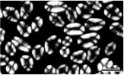

**3.4. Gelatinization behavior of starch**

The process of gelatinization for isolated chickpea starch was followed with use of a Brabender Visco-Amylo-Graph (Table 1).

Table 1. Raw data of Brabender Visco-Amylo-Graph for isolated chickpea starch

|  |  |  |  |  |
| --- | --- | --- | --- | --- |
| Point | Name | Time [HH:MM:SS] | Torque [BU] | Temperature [°C] |
| A | Beginning of gelatinization | 00:02:28 | 11 | 64.9 |
| B | Maximum viscosity | 00:04:48 | 59 | 70.4 |
| C | Start of holding period | 00:06:00 | 27 | 93.9 |
| D | Start of cooling period | 00:11:00 | 30 | 95.3 |
| E | End of cooling period | 00:20:00 | 144 | 50.1 |
| F | End of final holding period | 00:21:00 | 143 | 50.0 |
| B-D | Breakdown |  | 29 |  |
| E-D | Setback |  | 114 |  |

I have determined the gelatinization behavior of isolated chickpea starch (Table 1). The results indicate that isolated chickpea starch granules will start to swell, i.e. take up water at/around 64.9 °C, and continue to swell until a maximum is reached at/around 70.4 °C (increase in viscosity). If the maximum is surpassed, i.e. higher temperature, amylose chains begin to dissolve and the number and size of crystalline regions decreases. As a result, the starch granules rupture and part of the amylose and amylopectin will leak out to the surrounding solution (decrease in viscosity). When cooled for a long enough period, amylose and amylopection will start to realign itself at/around 50.1 °C to a more crystalline structure (increase in viscosity).

**3.5. Prepare starch solution**

1.004g of isolated chickpea starch was dissolved in 5.00 mL demineralized water. It was deemed necessary, after cool down, to supplement to 100 mL with demineralized water.

**3.6. Acid and Enzymatic hydrolysis of starch**

A solution of glucose or maltose, or a mixture of glucose, maltose and oligosaccharides was obtained.

Based on the first twenty minutes of acid and enzymatic hydrolysis, it was determined to observe a lower degree of hydrolysis for acid hydrolyzed chickpea starch than enzymatic hydrolyzed chickpea starch. The lower degree being due to the substrate-product based method of action for enzymatic hydrolysis.

**3.7. Reducing sugar content**

In Table 2 the absorbance of acid hydrolysis is shown.

Table 2. Raw data of the spectrophotometer: acid hydrolyzed chickpea starch

Carbohydrates | 8

|  |  |
| --- | --- |
| Number | Absorbance - 10x diluted |
| T0 [0 min.] | 0.120 |
| T1 [10 min.] | 0.222 |
| T2 [20 min.] | 0.625 |
| T3 [30 min] | 0.892 |
| T4 [40 min.] | 1.072 |

The spectrophotometer has been set at zero with a cuvette filled with demineralized water.

In Table 3 the absorbance of enzymatic hydrolysis is shown.

Table 3. Raw data of the spectrophotometer: enzyme hydrolyzed chickpea starch

|  |  |
| --- | --- |
| Number | Absorbance - 10x diluted |
| T0 [0 min.] | 0.127 |
| T1 [5 min.] | 0.405 |
| T2 [10 min.] | 0.599 |
| T3 [15 min] | 0.708 |
| T4 [20 min.] | 0.744 |

The spectrophotometer has been set at zero with a cuvette filled with demineralized water.

**3.8. Total (soluble) carbohydrates**

In Table 4 the absorbance of acid hydrolysis is shown.

Table 4. Raw data of the spectrophotometer: acid hydrolyzed chickpea starch

|  |  |
| --- | --- |
| Number | Absorbance - 100x diluted |
| T0 [0 min.] | 0.225 |
| T1 [10 min.] | 0.264 |
| T2 [20 min.] | 0.246 |
| T3 [30 min] | 0.253 |
| T4 [40 min.] | 0.235 |

The spectrophotometer has been set at zero with a cuvette filled with demineralized water.

In Table 5 the absorbance of enzymatic hydrolysis is shown.

Table 5. Raw data of the spectrophotometer: enzyme hydrolyzed chickpea starch

|  |  |
| --- | --- |
| Number | Absorbance - 100x diluted |
| T0 [0 min.] | 0.253 |
| T1 [5 min.] | 0.244 |
| T2 [10 min.] | 0.292 |
| T3 [15 min] | 0.254 |
| T4 [20 min.] | 0.230 |

The spectrophotometer has been set at zero with a cuvette filled with demineralized water.

**3.9. Research**

The results indicate that the degree of hydrolysis, expressed as dextrose-equivalents, increases over time for both methods of hydrolysis. Where the initial rate of reaction is higher for enzymatic hydrolysis than acid hydrolysis. Observed difference in reaction rate is best explained by the method of action. For enzymatic hydrolysis, the reaction rate depends on a equilibrium between substrate and product formed where the equilibirum is shifted to the left if more product is formed, i.e. reaction rate decreases over time.

Carbohydrates | 9

**3.10. Discussion**

My answers match the hypothesis. I expected these results, because I calculated everything sequentially. I used the formulas and hints you gave me. Hypotheses also helped. I'm sure I can explain the results.

For example, there is such equation y=0.0045x – 0.011.

There is a table in the results Raw data of the spectrophotometer: acid hydrolyzed and enzymatic hydrolyzed (two separate tables) chickpea starchю. There I took the first example 0.225 and put it in place of y.

0.225=0.0045x – 0.011.

Then I found x and multiplied by 100, because it says “absorbance – 100x diluted”.

Hypotheses and results are almost identical.

In “Starch isolation” section, it is hypothesized to isolate starch from chickpea seeds with a yield of 40% on a dry basis. In results I have isolated starch from chickpea seeds with a yield of 41.6% on a dry basis.

In section “Gelatinization behavior of starch”, it is hypothesized to observe the start of gelatinization at 60-65 °C, peak gelatinization at 65-70 °C, and retrogradation at 50-55 °C for isolated chickpea starch. The results indicate that isolated chickpea starch granules will start to swell, i.e. take up water at/around 64.9 °C, and continue to swell until a maximum is reached at/around 70.4 °C (increase in viscosity). When cooled for a long enough period, amylose and amylopection will start to realign itself at/around 50.1 °C to a more crystalline structure (increase in viscosity).

Carbohydrates are an interesting and not difficult topic. The tasks are also very exciting. I again reviewed the research assignments, and convinced that have answered all questions and accepted all the hypotheses.

**4. Conclusion**

In this study, I’ve researched chickpea seeds. Do they contain starch? How will it select it if present? How are starch granules defined? How to make a starch solution from the extracted chickpea starch? I’ve answered such questions. Here is my main material the seeds of chickpea. I’ve discovered the presence of starch in chickpea seeds using an iodine test. I have isolated starch from chickpea seeds with a yield of 41.6% on a dry basis. I have determined the granule morphology, i.e. size and shape, and location of the hilum of isolated chickpea starch granules. The size is 10-20 μm, shape is elliptical (oval), and hilum is located within the central dimple. I have determined the gelatinization behavior of isolated chickpea starch. Isolated chickpea starch granules will start to swell, i.e. take up water at/around 64.9 °C, and continue to swell until a maximum is reached at/around 70.4 °C (increase in viscosity). If the maximum is surpassed, i.e. higher temperature, amylose chains begin to dissolve and the number and size of crystalline regions decreases. As a result, the starch granules rupture and part of the amylose and amylopectin will leak out to the surrounding solution (decrease in viscosity). When cooled for a long enough period, amylose and amylopection will start to realign itself at/around 50.1 °C to a more crystalline structure (increase in viscosity). The degree of hydrolysis, expressed as dextrose-equivalents, increases over time for both methods of hydrolysis. Where the initial rate of reaction is higher for enzymatic hydrolysis than acid hydrolysis. Observed difference in reaction rate is best explained by the method of action. For enzymatic hydrolysis, the reaction rate depends on a equilibrium between substrate and product formed where the equilibirum is shifted to the left if more product is formed, i.e. reaction rate decreases over time.

Carbohydrates | 10

**5. References**

1. Lab Simulation Food Chemistry, Wageningen University, 2020
2. Course book Food Chemistry, Wageningen University, 2020
3. <https://sjors-kryt.labbuddy.net/experd#/?experdID=16051&gid=3690&user_type=user&uid=3690>
4. [AlfonsoClementea](https://www.sciencedirect.com/science/article/abs/pii/S0308814697001805#!)[RaúlSánchez-Vioquea](https://www.sciencedirect.com/science/article/abs/pii/S0308814697001805" \l "!)[JavierVioquea](https://www.sciencedirect.com/science/article/abs/pii/S0308814697001805" \l "!)[JuanBautistab](https://www.sciencedirect.com/science/article/abs/pii/S0308814697001805" \l "!)[FranciscoMillán](https://www.sciencedirect.com/science/article/abs/pii/S0308814697001805" \l "!) [Food Chemistry](https://www.sciencedirect.com/science/journal/03088146), [Volume 62, Issue 1](https://www.sciencedirect.com/science/journal/03088146/62/1), May 1998, Instituto de la Grasa, C.S.I.C. Apdo. 1078, 41012-Sevilla, Spain [Accessed 27 April 2020].
5. Cai, J., Cai, C., Man, J., Zhou, W., & Wei, C. (2014). Structural and functional properties of C-type starches. Carbohydrate polymers, 101, 289-300. Yangzhou University, Yangzhou 225009, China [Accessed 27 April 2020].
6. <https://scholar.google.com/scholar?hl=ru&as_sdt=0%2C5&q=starch+isolation+from+chickpea+seeds&btnG=> [Accessed 7 May 2020].

**6. Appendix**

**6.1. Raw chickpea seeds**

Table 1. Nutritional composition of raw chickpea seeds

|  |  |
| --- | --- |
| **Nutritional component** | **g/100g-dry weight basis** |
| Carbohydrates | 60-65 |
| Of which starch | 47-53 |
| Protein | 20-25 |
| Fat | 6-8 |
| Crude fiber | 3-4 |
| Ash | 3-4 |

**6.2. Presence of starch**

Sample

Negative result

Positive result

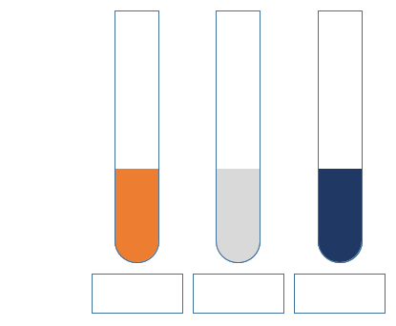

Figure 1. Testing the sample for the presence of starch using iodine test.

**6.3. Starch isolation**

Carbohydrates | 11

starch

Insoluble protein

soluble protein

lipids

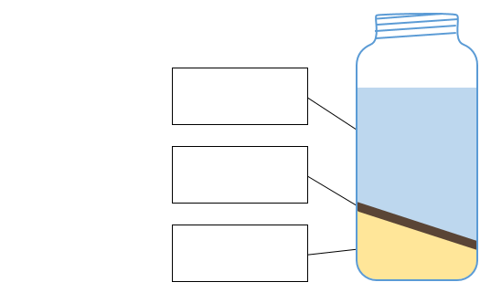

Figure 2. A possible outcome after centrifugation.

**6.4. Morphology of starch granules**

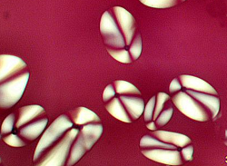

Figure 3. The hilum is the centre of a polarisation cross.

**6.5. Gelatinization behavior of starch**

Figure 4. Ordered visualization on the process of gelatinization.

Step 3.

Amylose starts leaking out

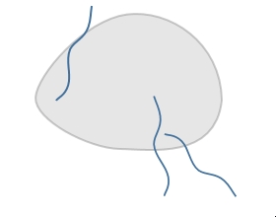

Step 1.

Suspended starch granules

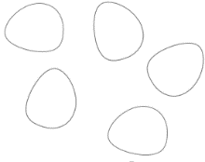

Step 4.

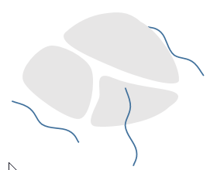

Granules fall apart

Step 2.



Swelling of starch granules

Step 5.

Carbohydrates | 12

Complete gelatinization

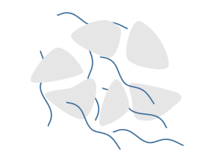

**6.6. Acid hydrolysis of starch**

Conditions which are used to start and stop the hydrolysis.

Start hydrolysis Stop hydrolysis

Ice

Decrease pH

Increase pH

Heat

**6.7. Reducing sugar content**

Acid and Enzymatic hydrolysis

|  |  |  |
| --- | --- | --- |
| **Number** | **Cglucose (µg/mL)** | **Absorbance** |
| 1 | 0 | 0.000 |
| 2 | 30 | 0.169 |
| 3 | 60 | 0.475 |
| 4 | 90 | 0.660 |
| 5 | 120 | 0.918 |
| 6 | 150 | 1.090 |

Table 2. Raw data of the spectrophotometer: calibration curve

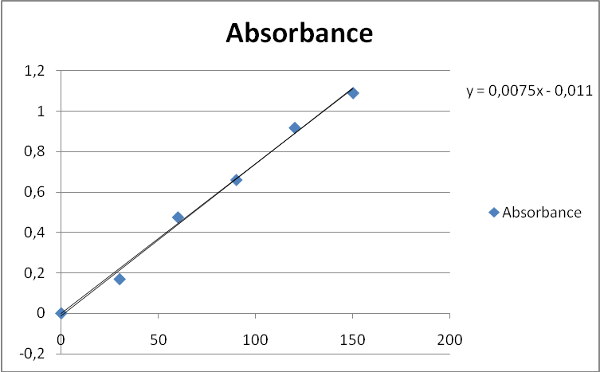

Figure 5. Calibration curve

**6.8. Total (soluble) carbohydrates**

Acid and Enzymatic hydrolysis

|  |  |  |
| --- | --- | --- |
| **Number** | **Cglucose (µg/mL)** | **Absorbance** |
| 1 | 0.00 | 0.022 |
| 2 | 18.75 | 0.073 |
| 3 | 37.50 | 0.127 |
| 4 | 75.00 | 0.336  Carbohydrates | 13 |
| 5 | 112.50 | 0.441 |
| 6 | 150.00 | 0.692 |
| 7 | 225.00 | 1.023 |

Table 3. Raw data of the spectrophotometer: calibration curve

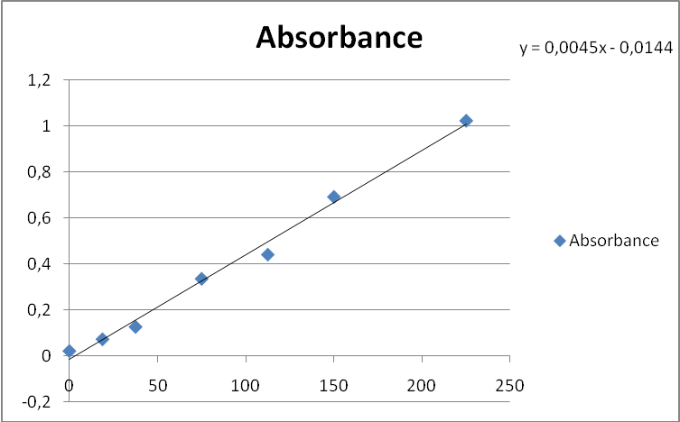

Figure 6. Calibration curve