MINISTRY OF EDUCATION AND SCIENCE OF THE RUSSIAN FEDERATION
Federal state budgetary educational institution of higher education
«Voronezh State Forestry University
named after G.F. Morozov»

RESEARCH PAPER
on the subject:
«Ways of carrying out the processes of artistic design of products made of wood»

Student group DM2-201-OB
Elfimova Y.P.

Voronezh 2021
WAYS OF MAKING ARTISTIC PRODUCTS FROM WOOD
Extend the technological possibilities of producing artistic woodwork by additional devices. Various designs of devices for milling, mainly artistic ornaments, were proposed by M.S. Glikin, later improved and supplemented by M.M. Chernykh, A.I. Pyankov, V.Y. Krapivkin, Y.V. Lozhkin. The designs of the fixtures are mainly applicable to lathe equipment and do not allow for highly artistic bas-relief products or complex sculptural compositions. Examples of finished products are shown in Fig. 1
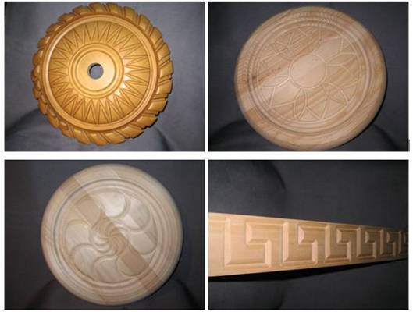

Fig. 1 Products obtained with the use of additional fixtures for lathes
To mechanize the process of making artistic wood products, including decorative and ornamental additions to furniture and architectural interior parts, milling and copying machines are used. With the help of such equipment you can perform various elements of carving - round rosettes in the form of multi-petal flowers, swirling rosettes, rasport belt friezes with curved wave-like partitioning, balusters and even highly sculptural, bas-relief and high relief details and much more.
The principle of working on such equipment is to manually copy the sample template of the product with simultaneous milling of the workpiece.
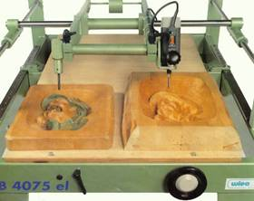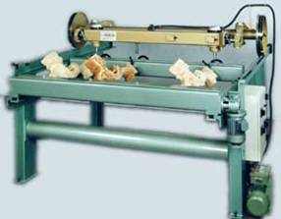

Fig. 2 Left - milling bas-relief on the copying machine with pantograph; right - double-spindle volumetric-copying milling machine Andreoni
The machine operator drives the pin along all the contours, recesses, and convexities of the pattern while moving the table up and down; if desired, the pattern can be relocated and machined in a different orthogonal plane. The spindle, connected to the pin, repeats all its movements, making an exact copy of the sample model. An experienced master artist, with a good eye and precise movements, can execute his ornamental compositions directly on the machine. In this case, the machine is seen as a device that facilitates the master's labor and increases productivity.
Turning or turning is one of the main machining operations performed on woodworking machines of the turning group, usually with rotary movement of the product and progressive movement of the cutter. Modern woodworking companies increasingly use not only conventional lathes, where processing is carried out manually by a master, but also machines of the turning and milling group. The machining tool of such equipment is a special disk milling cutter or end milling cutter. Such machines carry out processing automatically according to the set control program (Fig. 3). The operator is only required to change the workpiece and run the program in a new process cycle.
Despite the widespread use of turning equipment in production, the range of products produced is usually limited to parts that are shaped like bodies of rotation. That is why lathes are mostly used for the production of artistic balusters - supporting structures of stairway railings (Fig. 3).
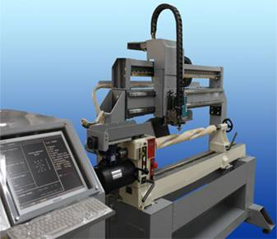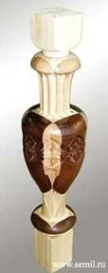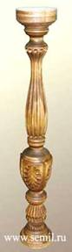

Fig. 3 CNC milling lathe "ROBOR" and balusters made on it
The surface quality after machining on lathes always requires manual sanding of the surface and reduces the overall productivity of the manufacturing process. It should be noted that today, thanks to the developments of SEMIL Scientific and Production Association, Izhevsk, the lathe-milling equipment allows to perform complex products of irregular shape, which include, for example, sculptures. Despite the fundamental differences in the types of equipment, the problematic issues that arise when machining sculptures on lathes fully correspond to the drawbacks of machining on three-axis CNC machines.
Another technology - wood stamping technology is associated with its pressure treatment with heated dies and punches. The wood is steamed beforehand. High cost of stamps and the inability to obtain three-dimensional relief illustrations in pressing this technology have found only wide application in the manufacture of souvenirs in the high production batches, for example, caskets, but not exclusive products for a particular order of small batches.
Technology of laser engraving of wood, as well as laser burning surfaces on raster drawings to date are not applicable to obtain three-dimensional images on wood.
The last considered technologies are not able to reveal three-dimensional bas-relief, high relief or sculptural forms in solid wood. Therefore, we will only mention them as existing types of artistic woodworking, mainly used for the application of texture and shallow drawings on the flat surfaces of wood products.

