MINISTRY OF EDUCATION AND SCIENCE OF THE RUSSIAN FEDERATION
Federal state budgetary educational institution of higher education
«Voronezh State Forestry University
named after G.F. Morozov»

RESEARCH PAPER
on the subject:
«Ways of carrying out the processes of artistic design of products made of glass»

Student group DM2-201-OB
Elfimova Y.P.

Voronezh 2022
Educational express-design of an art object made of glass
In the training of an artist-designer, theoretical knowledge and practical experience are important links in conveying the structural, functional and artistic properties of various building materials.
Effective work with materials implies in-depth knowledge of the qualities and properties of the material, the skill to work with it during the design and implementation of the design intentions both in architectural practice and in the field of decorative and applied art.
The new genre of landscape glass used in the external environment, formed in the context of the development of the author's studio glass, in turn, closely related to the worldwide movement, called "Glass Studio movement". The artistic meaning of this process lies in the purely experimental nature of the search for the author's style, in the desire to find modern means of expression. In the process of creativity the principles of form creation change radically, expanding the boundaries of the genre, a new understanding of the plastic nature of the image. In art history literature covering the art of the present technotronic age, landscape glass and ceramics remain little-noticed, probably due to the fact that the artistic specificity of the genre has not yet been defined. Nevertheless, this form of creativity brings about decisive changes in the formation of new meanings of artistic and plastic images in decorative art.
In this article we will consider the author's methodology of teaching the discipline of art object design from glass for placement in the existing urban environment, tested at the Krasnoyarsk State Institute of Arts (at the Department of "Environmental Design") with the target audience of trainees from the People's Republic of China - students of Hulunbuir Institute. The task was complicated by the conditions of the students' short internship, in the structure of which a limited time of 72 hours was set aside for mastering the curriculum of the mentioned discipline.
Experimental methodology of teaching this design discipline is aimed at revealing the students' capabilities, their knowledge and practical skills in creating three-dimensional objects from a given material, in this case, glass, in a short time.
During the internship students during the whole period of training, training tasks were built into a sequence of gradually complicating tasks - from developing a palette of structural properties of the material to organizing three-dimensional layouts. Here are examples of such tasks:
Stage 1. Theoretical pre-project research. Theme: glass.
Analogues are selected, modern possibilities of glass processing are studied, the use of which can reveal new properties of artistic expressiveness of glass. From various sources - books, magazines, Internet sources - the most interesting variants of glass use in the interior are selected.
Theoretical investigation includes the following sections:
- basic types of glass: translucent and non-transparent glass;
- constructional and decorative glass: coloured, patterned, frosted, multi-layered, hardened, window, window units, double-glass units, profile glass;
- basic glass properties: reflection, fragility, optical properties, light transmission, etc.;
- glass processing methods, modern technologies: milling, fusing, multiplex;
- opportunities for chemical and mechanical treatment of glass. Chemical influence: dyes, brighteners, decolorizers, silencers, oxidizers, reducing agents; etching, matting of glass; mechanical processing of glass includes sand-blasting, ultrasonic, cutting, grinding, engraving;
- basic ways of fastening, connections of glass parts: gluing, metal fastening, etc. (fig. 1).
Stage 2: Creating an artistic and expressive palette of tectonic material properties.
For full disclosure of the author's idea, an individual palette of graphic means and techniques is developed, with the help of which it is important to convey the color and texture of the material in different physical states as accurately as possible. The palette means the most expressive surface characteristics of glass, such as corrugated glass, sandblasted, broken glass, etc., depicted in a drawing on a flatbed. It is also necessary to study the knots, fixings of glass parts, variants of connecting elements - to understand the possibilities of installation of the art object in the process of realization. The pencil textures are assembled on a tablet (Fig. 2).
Stage 3: Performing exploratory sketches-mock-ups based on the collected material on the given topic.
At this stage, emphasis is placed on the harmonious combination of functional and structural and decorative properties of materials. In the process of searching for form and image, the trainee uses a wide range of expressive aesthetic and artistic properties of the studied material, most actively revealing its plastic, constructive and decorative features. When making a model, a simulation of a design-practical situation takes place, where the trainee gets an idea of the role of materials as an integral component of the artistic conception, and also learns how to apply materials for specific conditions, taking into account the tasks set, in compliance with the necessary requirements.
Operating with the set of aesthetic characteristics found in the previous task, the student attempts to achieve a bright emotional expressive image of the object through paper and cardboard modeling and, at the same time, develops three-dimensional thinking by comparing volumes and planes of the designed object, selecting scale and harmonizing proportions (Fig. 3-9).
Stage 4: The final version of the graphical representation (presentation) of the design proposal in the appropriate scale and material. Formation of the graphical representation (submission) of the project.
At this stage the methodical task is to form a final layout on the basis of mastering the layout technology of three-dimensional modeling and process its photos with raster graphics in computer programs for more visual implementation of the design intentions in the field of creating objects of the spatial environment.
It is important to show the object in relation to the architectural and spatial quality of the environment for which it is designed. For this purpose, a selection of potentially suitable spaces is made, of which the most appropriate one is approved. On graphic sheets in the collage technique, the student depicts a photomontage of the designed object in an architectural exterior or interior environment (Fig. 10-14). The graphic presentation (presentation, exposition) of the design proposal is provided with orthogonal projections of the object or sweeps to convey the scale and structure of the developed object more clearly.
Conclusion. Thus, the consistently stated methodological tasks of a specific training program of design-projection of a glass object for the urban environment, intended for development in a short time, are aimed at disclosure of students' capabilities, their knowledge and practical skills in creating three-dimensional objects from a specified material in a short time.
The results of the implementation of this training program assume the following results:
systematization of knowledge and skills of students to work with "construction" material;
activation of cognitive activity of students and development of their creative thinking;
optimization of training design time by increasing theoretical knowledge and replacing the stages of 3D (volume computer) modeling by modeling.
Each block of tasks is aimed at studying the technology of working with the material, revealing its structural qualities, accumulation of the author's methods of material processing and possibilities of application in artistic design.

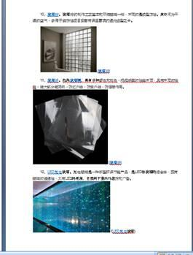
Figure 1. Example of design of the explanatory note; author - trainee Liu Yang
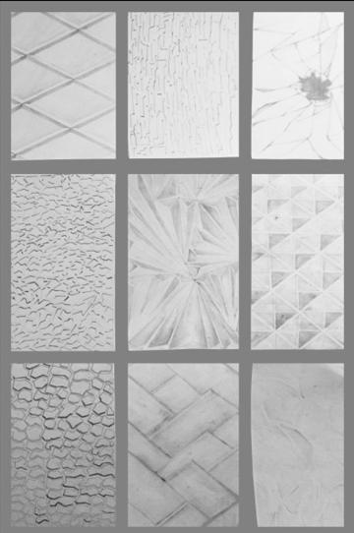
Figure 2. Example of the design of the results of the study of the palette of tectonic properties of the material; the authors are trainees from the Hulunbuir Institute
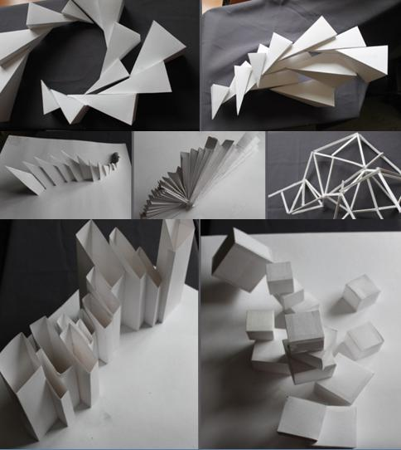
Figures 3-9. Example of search layouts; the authors are trainees from Hulunbuir Institute
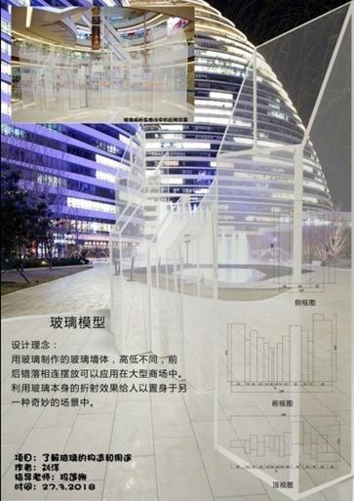
Figure 10. Graphic exposition of the project; author - trainee Liu Yang
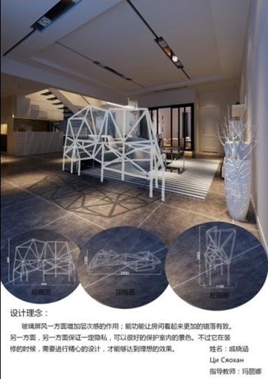
Fig. 11. Graphic exposition of the project; author - trainee Qi Xiaohan
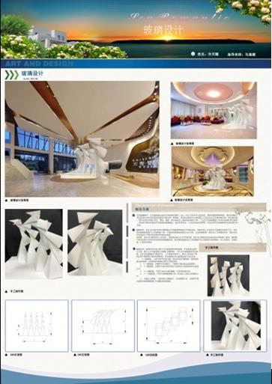
Fig. 12. Graphic exposition of the project; author - trainee Xu Tianqi
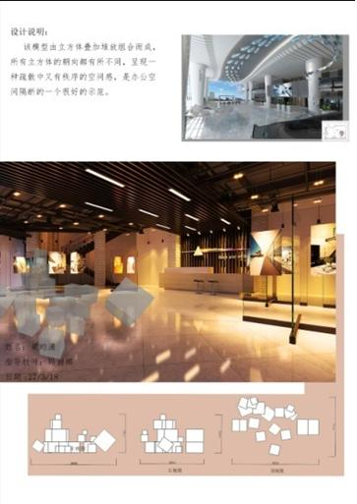
Fig. 13. Graphic exposition of the project; author - trainee Aya Yunxiao
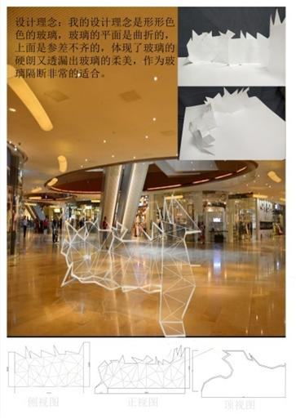
Fig. 14. Graphic exposition of the project; author - trainee Wang Jiehui

